1. Question: <https://leetcode.com/problems/two-sum/description/>

Solution: <https://leetcode.com/problems/two-sum/post-solution/?submissionId=1342608061>

Screenshot: 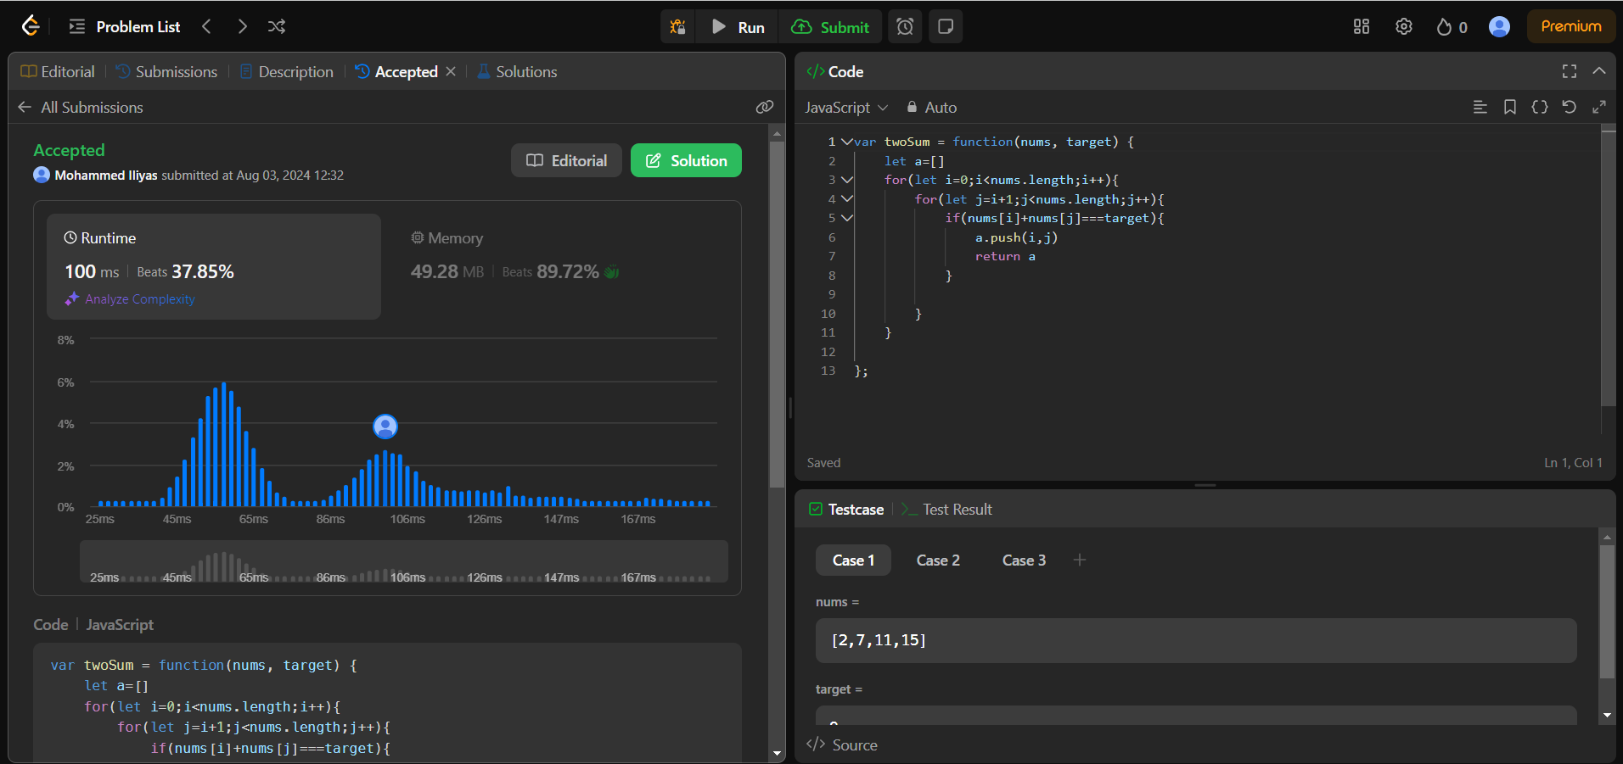

Description: Time Complexity O(n2)

Space Complexity O(n)

1. Question: <https://leetcode.com/problems/3sum/description/>

Solution: <https://leetcode.com/problems/3sum/post-solution/?submissionId=1342628223>

Screenshot:

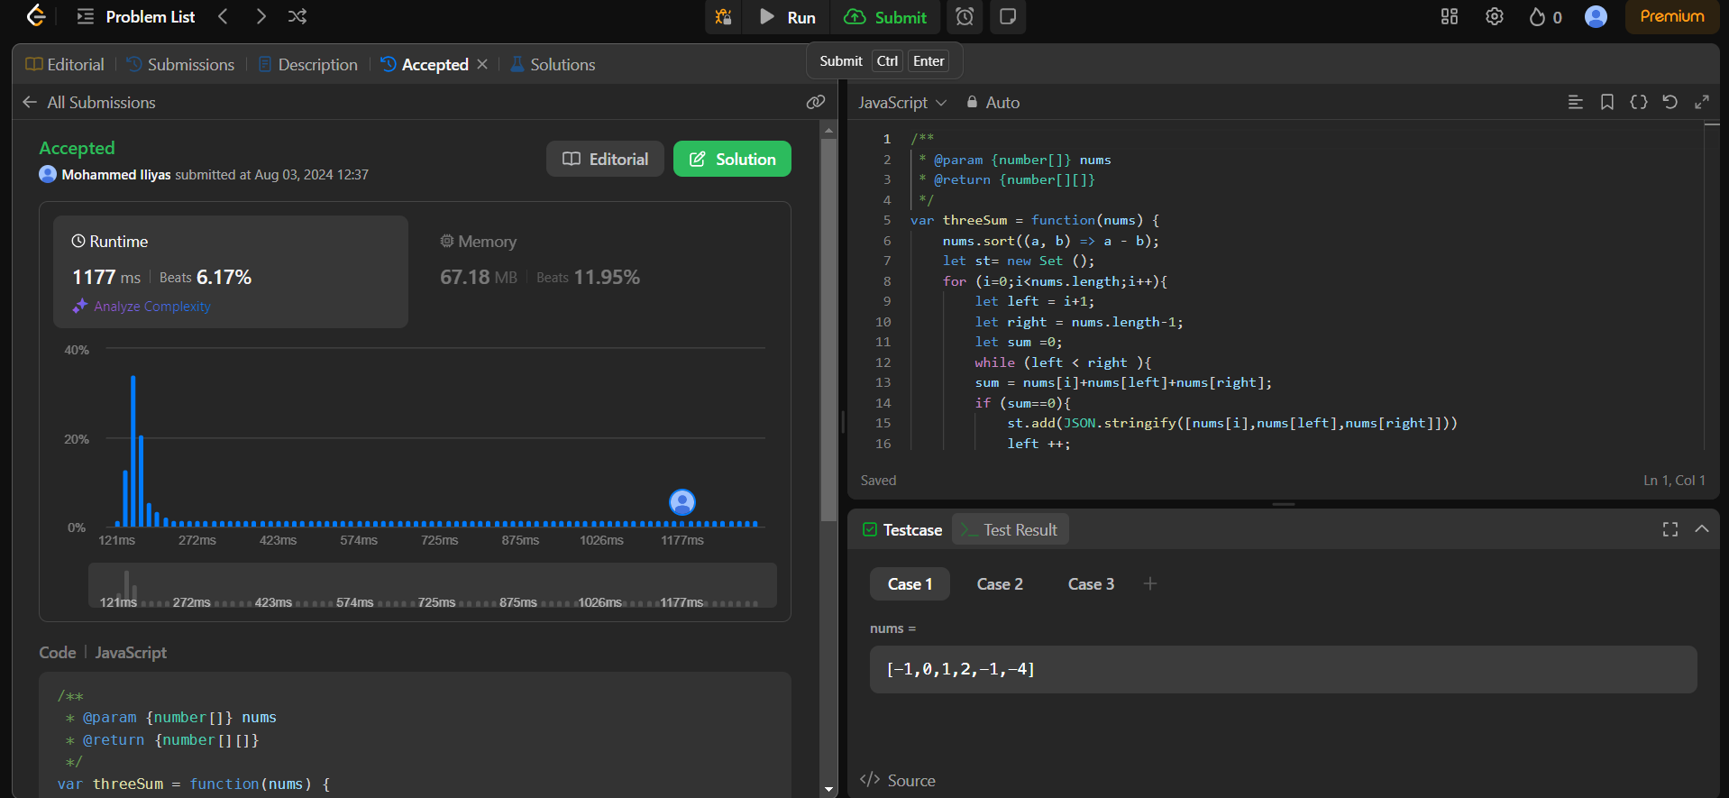

Description: Time Complexity O(n)

Space Complexity O(n)

1. Question: <https://leetcode.com/problems/long-pressed-name/description/>

Solution: <https://leetcode.com/problems/long-pressed-name/post-solution/?submissionId=1342622943>

Screenshot:

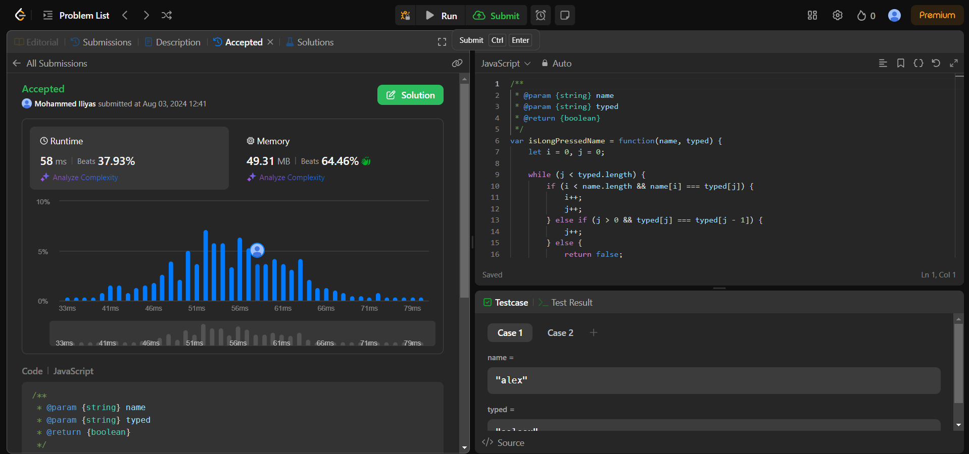

Description: Time Complexity O(n)

Space Complexity O(n)

4)Question: <https://leetcode.com/problems/max-chunks-to-make-sorted/description/>

Solution: <https://leetcode.com/problems/max-chunks-to-make-sorted/post-solution/?submissionId=1342630908>

Screenshot:

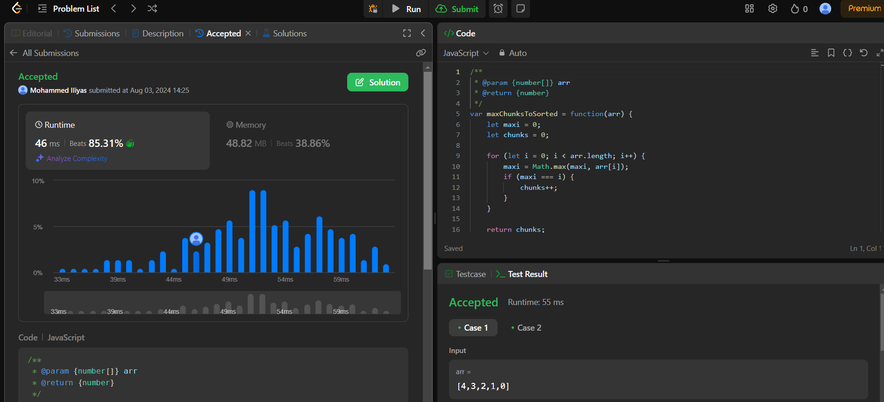

Description: Time Complexity O(n)

Space Complexity O(n)

5)Question: <https://leetcode.com/problems/sort-colors/description/>

Solution: <https://leetcode.com/problems/sort-colors/post-solution/?submissionId=1342631876>

Screenshot: 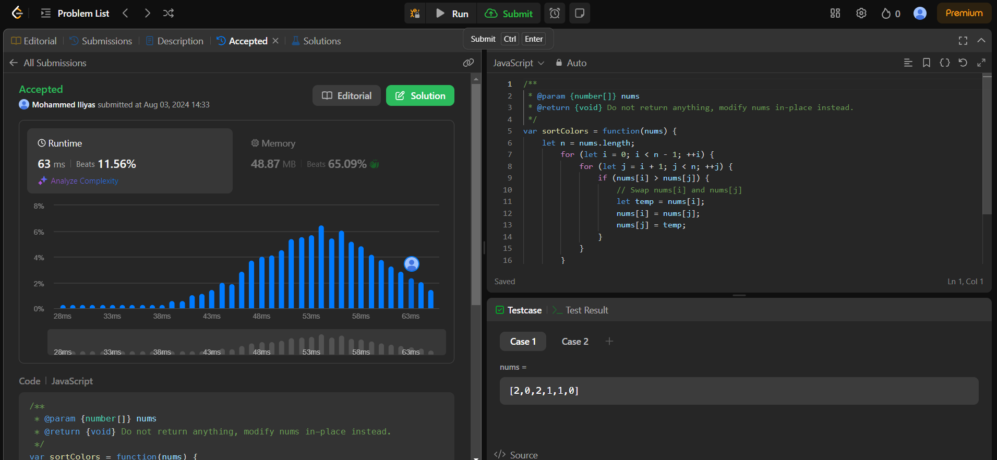

Description: Time Complexity O(n2)

Space Complexity O(1)

6)Question: <https://leetcode.com/problems/maximum-subarray/description/>

Solution: <https://leetcode.com/problems/maximum-subarray/post-solution/?submissionId=1342641528>

Screenshot: 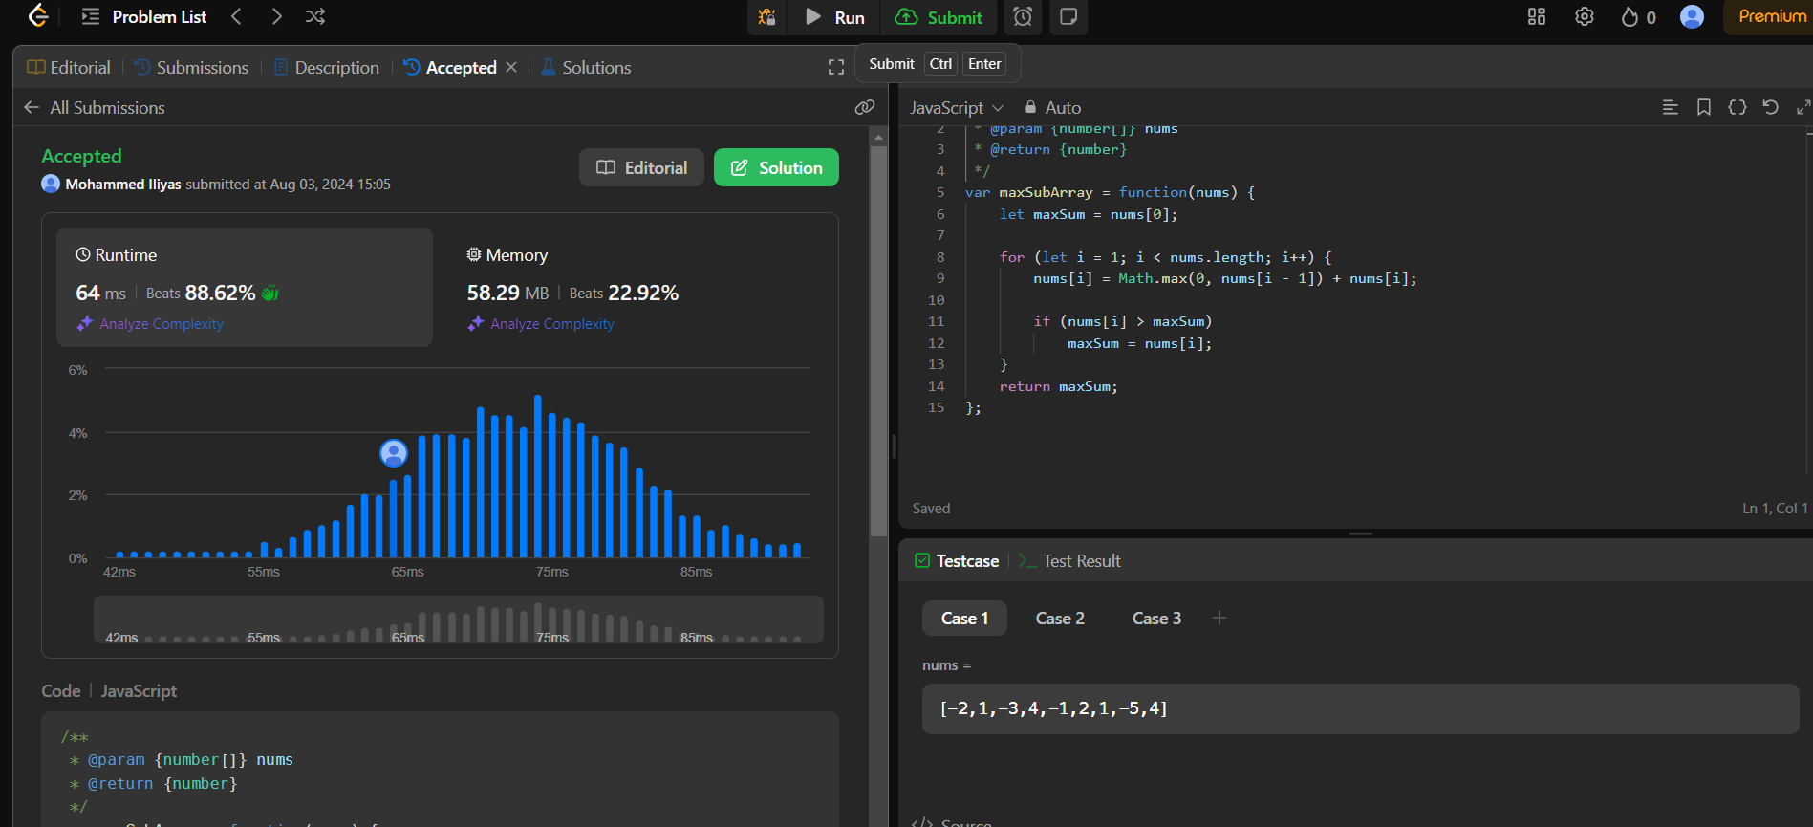

Description: Time Complexity O(n)

Space Complexity O(1)